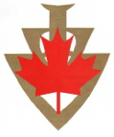
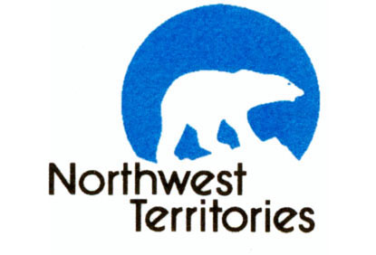
Mark Your Calendars!

See the North with ‘2020’ Vision!
The Canadian Volkssport Federation is excited to announce that our 2020 Convention and AGM will be held in Yellowknife, Northwest Territories, June 12-14.

The land of the midnight sun, Yellowknife, beyond the 60th parallel, awaits adventurous Volkssporters from across Canada, the USA and the rest of the Volkssport world.

Yellowknife sits on the shore of the world’s 10th largest lake, Great Slave Lake, and enjoys summer days with nearly 24 hours of sunlight. Once a gold rush town and now a diamond mining town, Yellowknife is the hub of northern activities. Boasting several beautiful Volkssport sanctioned city and backwoods walks, you will be impressed with this historic city of 20,000 people. Keep your eyes open for northern bird and wildlife while walking.

The average daytime temperatures in June are 13-20C – ideal walking weather. June promises between 19 and 20 hours of sunlight a day, a truly unique experience.

Check out this site for good information about Yellowknife in June: https://ykonline.ca/yellowknife-in-june/

This is a once in a lifetime adventure into Canada’s north country, with the added bonus of walking with new and old Volkssport friends from across Canada and beyond. Join us on this adventure.

An all-encompassing bus tour, featuring spectacular waterfalls and northern scenery is being arranged. More details to follow shortly. Note: if you’re planning on taking the bus tour, hotel accommodations will be taken care of.

Book your hotel now.

CHATEAU NOVA YELLOWKNIFE
Group Reservation#: 2808538
Toll Free: 1-866-722-6682

We have an exceptional group rate of $179/night for the best hotel accommodations in Yellowknife. Check out the facilities and reserve your room early. http://www.novahotels.ca/chateau-nova-yellowknife/

Registrations for the Convention will commence in April 2019. Stay tuned for more details.

We look forward to seeing you at this very special Volkssporting event, sponsored by the Canadian Volkssport Federation.

